DML commands – INSERT, SELECT
- INSERT
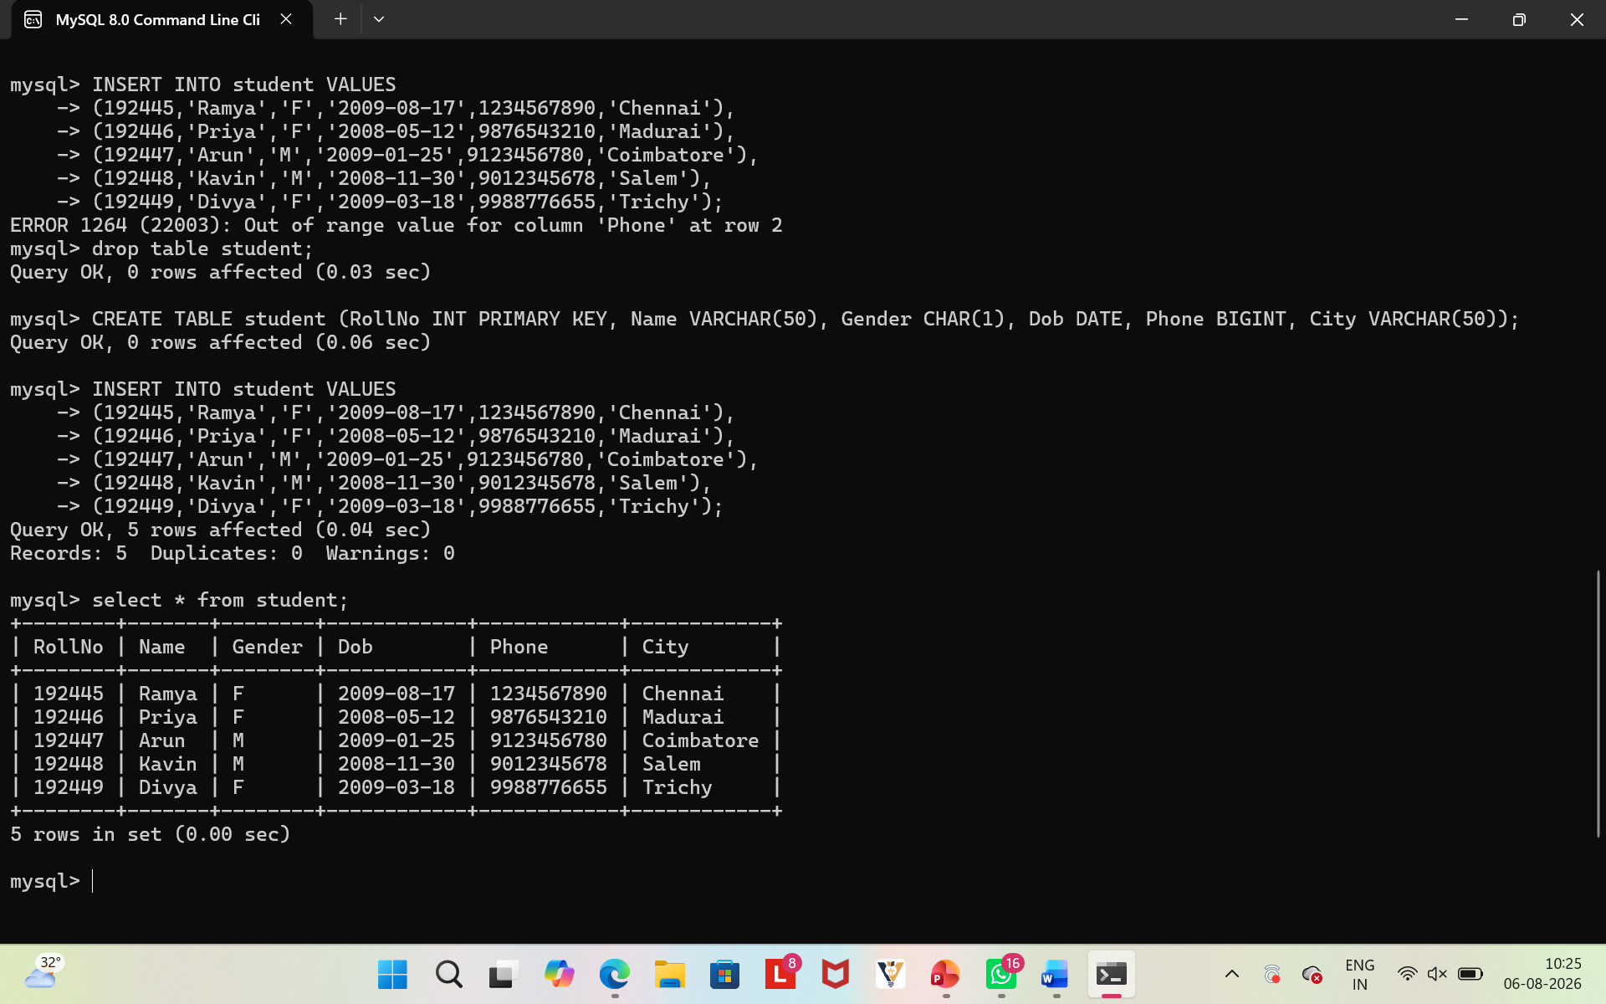
- SELECT
